Natas Level 0

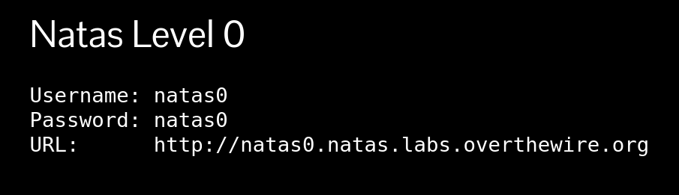

Open the link on your browser & log in.
Username: natas0
Password: natas0

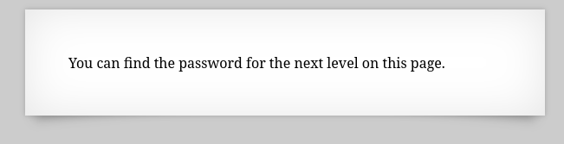

Click-right button on your mouse. Then click View page source.
Password is: 0nzCigAq7t2iALyvU9xcHlYN4MlkIwlq
Now go and play second level.

Natas Level 0 → Level 1
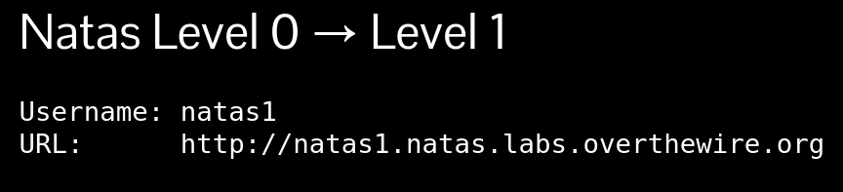

Open the link on your browser & log in.
Username: natas1
Password: 0nzCigAq7t2iALyvU9xcHlYN4MlkIwlq

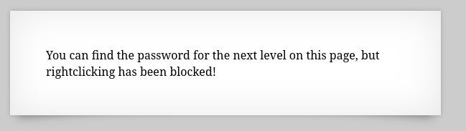
Click right button on your mouse. Then click View page source.

Password is: TguMNxKo1DSa1tujBLuZJnDUlCcUAPlI
Now go and play next level.

Natas Level 1 → Level 2
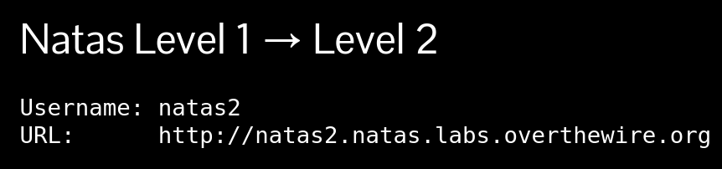
Open the link on your browser & log in.
Username: natas2
Password: TguMNxKo1DSa1tujBLuZJnDUlCcUAPlI
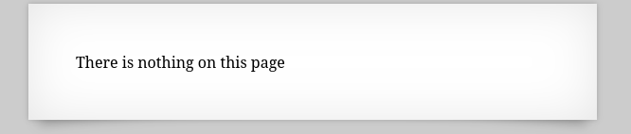
Click right button on your mouse. Then click View page source.
There is nothing on the page. But we found a path (files/pixel.png)

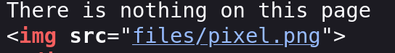
Now open this link: http://natas2.natas.labs.overthewire.org/files/
Now we found
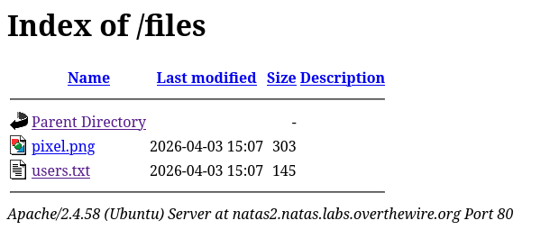
Click the users.txt
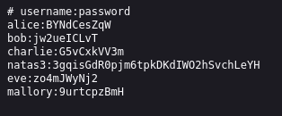
Password is: 3gqisGdR0pjm6tpkDKdIWO2hSvchLeYH
Now go and play next level.

Natas Level 2 → Level 3
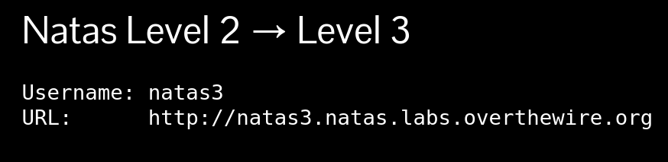
Open the link on your browser & log in.
Username: natas3
Password is: 3gqisGdR0pjm6tpkDKdIWO2hSvchLeYH

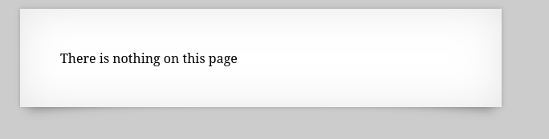
There is nothing on this page. Now check the robots.txt so,
Link is: natas3.natas.labs.overthewire.org/robots.txt
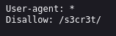
Here we found a new path.
Then search: http://natas3.natas.labs.overthewire.org//s3cr3t/
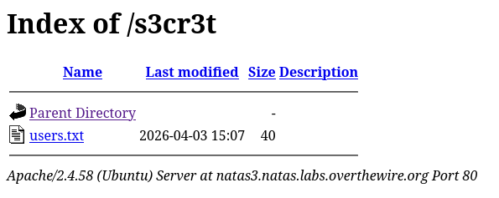
Now click users.txt.
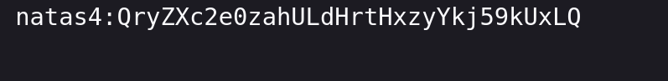
Password is: QryZXc2e0zahULdHrtHxzyYkj59kUxLQ
Now go and play next level.

Natas Level 3 → Level 4
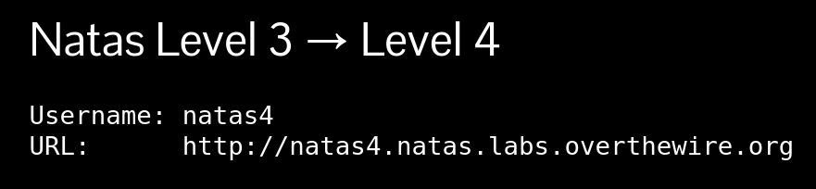
Open the link on your browser & log in.
Username: natas4
Password is: QryZXc2e0zahULdHrtHxzyYkj59kUxLQ
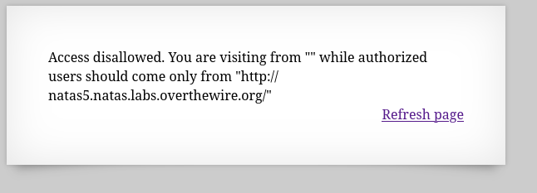
Open the burpsuite and browser.
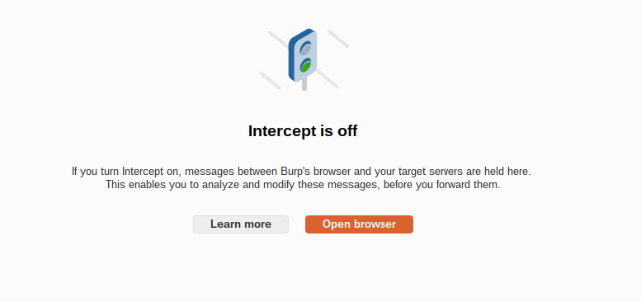
Open the link http://natas4.natas.labs.overthewire.org and sign in
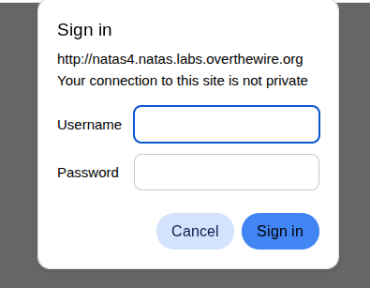
Username: natas4
Password is: QryZXc2e0zahULdHrtHxzyYkj59kUxLQ
Intercept on the burpsuite, then refresh the page
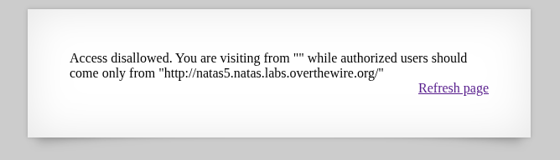
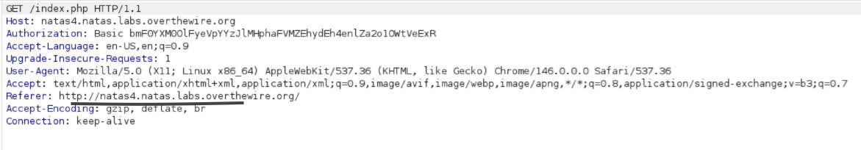
Replace 4 with 5, right-click the request, and send it to Repeater.
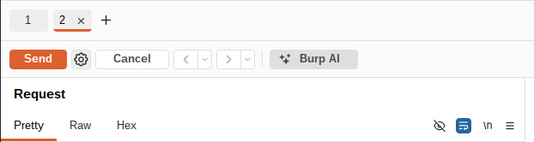
Click the sent button.

Password is : 0n35PkggAPm2zbEpOU802c0x0Msn1ToK
Now go and play next level.

Natas Level 4 → Level 5
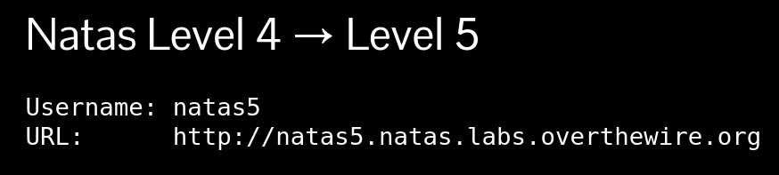
Open the link on your browser & log in.
Username: natas5
Password is: 0n35PkggAPm2zbEpOU802c0x0Msn1ToK
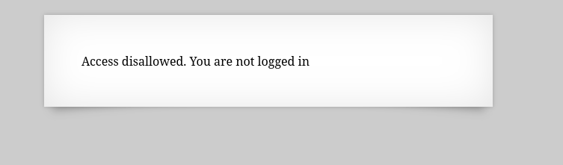

Click-right button on your mouse. Then click inspect, then go to the storage option.
Go to the cookies.
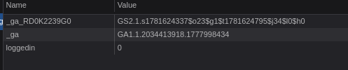

Replace 0 with 1 and refresh the web page.

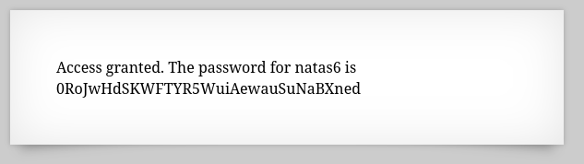
Password is : 0RoJwHdSKWFTYR5WuiAewauSuNaBXned
Now go and play next level.

Natas Level 5 → Level 6
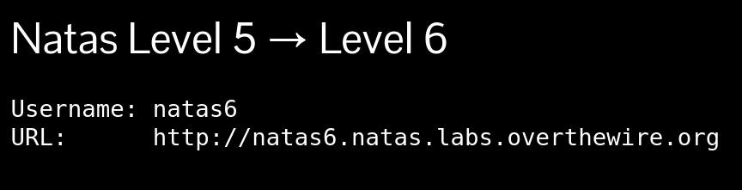
Open the link on your browser & log in.
Username: natas6
Password is: 0RoJwHdSKWFTYR5WuiAewauSuNaBXned
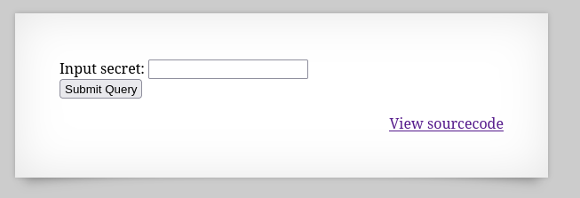
Go to the View sourcecode.
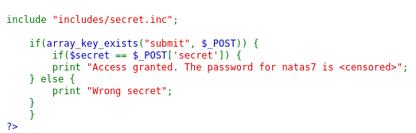
here , they give us a path. Now go to the link is http://natas6.natas.labs.overthewire.org/includes/secret.inc
There is nothing.Click-right button on your mouse. Then click view page source option
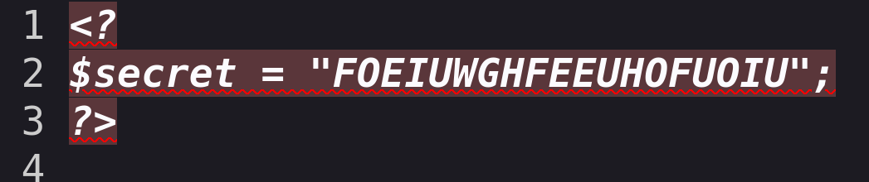Secret code is FOEIUWGHFEEUHOFUOIU. Copy that paste there.
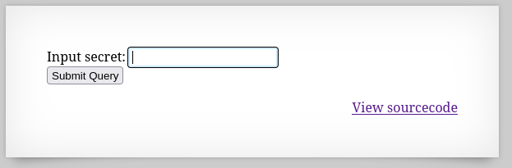
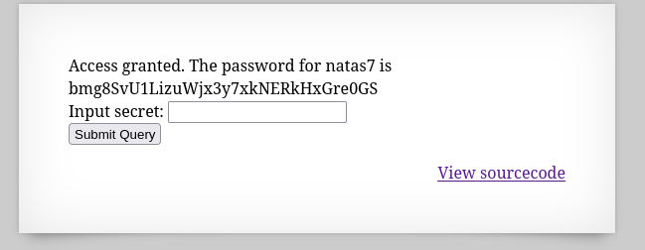
Password is bmg8SvU1LizuWjx3y7xkNERkHxGre0GS
Now go and play next level.

Natas Level 6 → Level 7
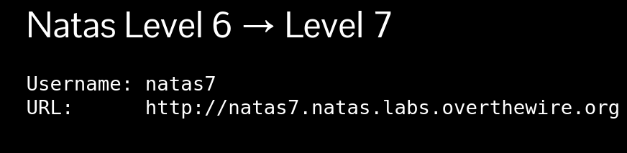
Open the link on your browser & log in.
Username: natas7
Password is: bmg8SvU1LizuWjx3y7xkNERkHxGre0GS
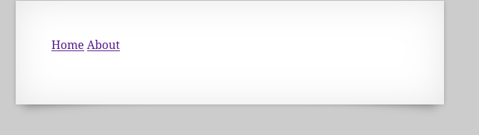
Click on home page.now open the source code.
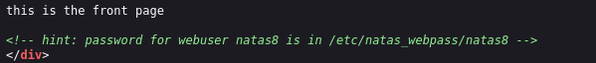
They give us a hint.Now copy the path, then open the link http://natas7.natas.labs.overthewire.org/index.php?page=/etc/natas_webpass/natas8
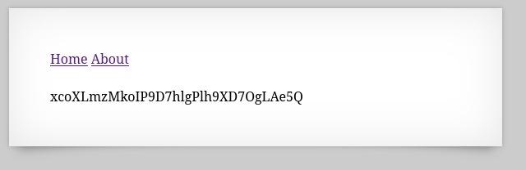
Password is xcoXLmzMkoIP9D7hlgPlh9XD7OgLAe5Q
Now go and play next level.

Natas Level 7 → Level 8
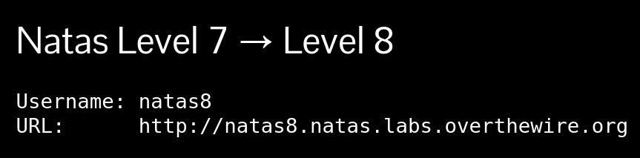
Open the link on your browser & log in.
Username: natas8
Password is : xcoXLmzMkoIP9D7hlgPlh9XD7OgLAe5Q
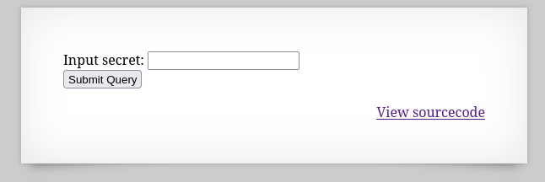
Click the View sourcecode.
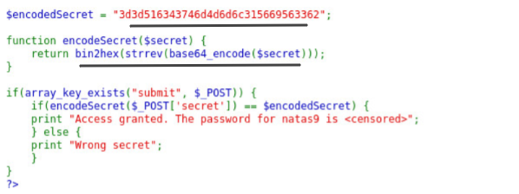
Copy the number 3d3d516343746d4d6d6c315669563362
Go to the cyberchef and paste the number
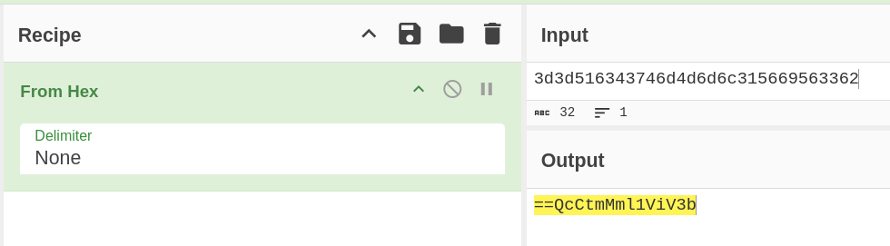
Now go to any online tool and reverse the string. like,
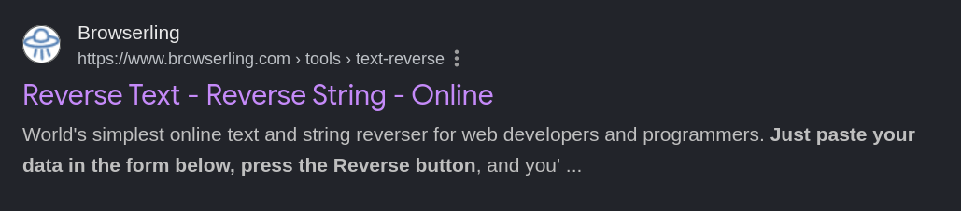
b3ViV1lmMmtCcQ==
Decode it by base64.
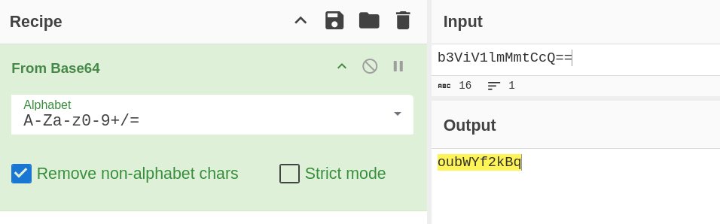
Secret code is oubWYf2kBq
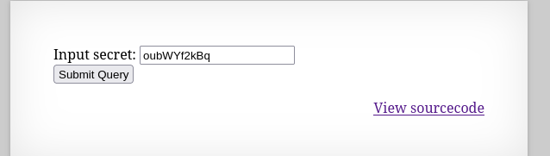
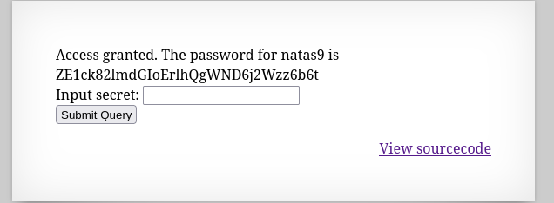
Password is ZE1ck82lmdGIoErlhQgWND6j2Wzz6b6t
Now go and play next level.

Natas Level 8 → Level 9
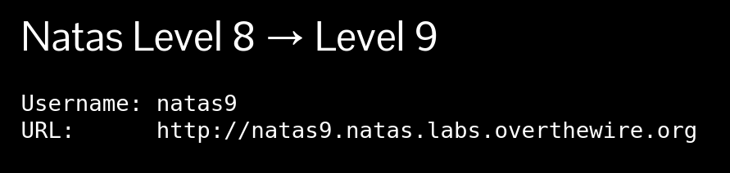
Open the link on your browser & log in.
Username: natas9
Password is ZE1ck82lmdGIoErlhQgWND6j2Wzz6b6t

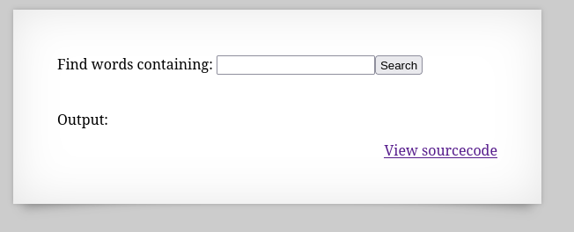
Click on View sourcecode.
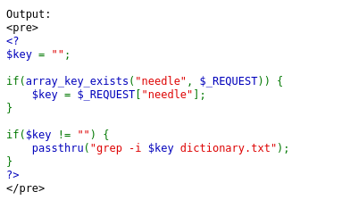
They give us a text file.Now, we find out the key.
grep -i; cat /etc/natas_webpass/natas10; dictionary.txt
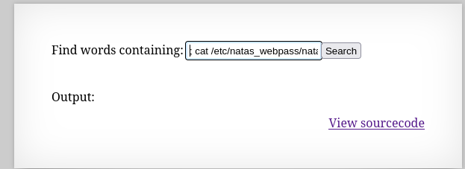
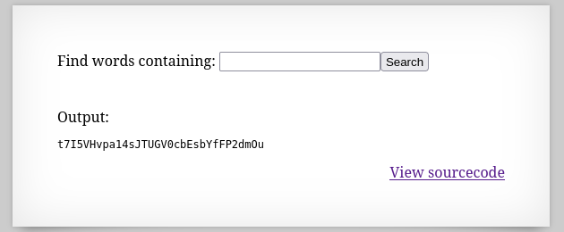
Password is t7I5VHvpa14sJTUGV0cbEsbYfFP2dmOu
Now go and play second level.

Natas Level 9 → Level 10
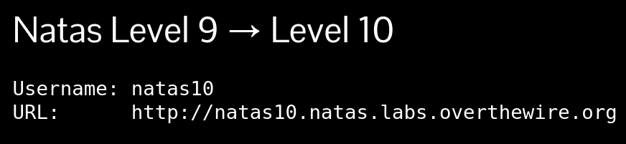
Open the link on your browser & log in.
Username: natas10
Password is t7I5VHvpa14sJTUGV0cbEsbYfFP2dmOu

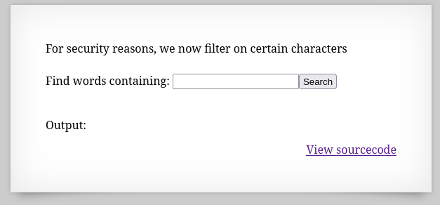
Click on View sourcecode.
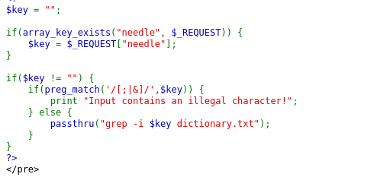
The key is a /etc/natas_webpass/natas11 to find the password.
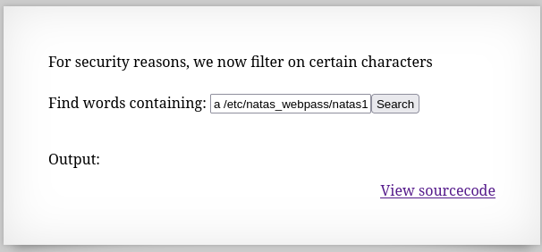
Now search.
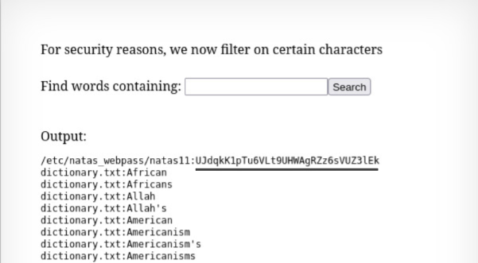
Password is UJdqkK1pTu6VLt9UHWAgRZz6sVUZ3lEk
Now go and play second level.

